SARTHAK KESARWANI
1NT19IS141

Hybrid Application Development

Android SQLite Database

XML Code:
ActivityMain.xml

<?xml version="1.0" encoding="utf-8"?>
<LinearLayout xmlns:android="http://schemas.android.com/apk/res/android"
xmlns:app="http://schemas.android.com/apk/res-auto"
xmlns:tools="http://schemas.android.com/tools"
android:layout_width="match_parent"
android:layout_height="match_parent"
android:orientation="vertical"
android:layout_margin="10dp"
tools:context=".MainActivity">
<EditText
android:layout_width="match_parent"
android:layout_height="wrap_content"
android:hint="Enter username"
android:textSize="30dp"
android:id="@+id/uname">
</EditText>
<EditText
android:layout_width="match_parent"
android:layout_height="wrap_content"
android:hint="Enter password"
android:textSize="30dp"
android:id="@+id/upass">
</EditText>
<LinearLayout
android:layout_width="wrap_content"
android:layout_height="wrap_content"
android:orientation="horizontal"
android:layout_gravity="center">
<Button
android:layout_width="match_parent"
android:layout_height="wrap_content"
android:text="Login"
android:id="@+id/login">
</Button>
<Button
android:layout_width="match_parent"
android:layout_height="wrap_content"
android:layout_marginLeft="10dp"
android:text="Register"
android:id="@+id/register">
</Button>
</LinearLayout>
<LinearLayout
android:layout_width="wrap_content"
android:layout_height="wrap_content"
android:orientation="horizontal"
android:layout_gravity="center">
<Button
android:layout_width="match_parent"
android:layout_height="wrap_content"
android:text="Delete"
android:id="@+id/delete">
</Button>
<Button
android:layout_width="match_parent"
android:layout_height="wrap_content"
android:layout_marginLeft="10dp"
android:text="Update"
android:id="@+id/update">
</Button>
</LinearLayout>
<Button
android:layout_width="match_parent"
android:layout_height="wrap_content"
android:text="Display"
android:id="@+id/display">
</Button>
<TextView
android:layout_width="match_parent"
android:layout_height="wrap_content"
android:id="@+id/res"
android:textSize="30dp">
</TextView>
</LinearLayout>

Welcome.xml

<?xml version="1.0" encoding="utf-8"?>
<LinearLayout
xmlns:android="http://schemas.android.com/apk/res/android"
xmlns:app="http://schemas.android.com/apk/res-auto"
xmlns:tools="http://schemas.android.com/tools"
android:layout_width="match_parent"
android:layout_height="match_parent"
android:orientation="vertical"
android:gravity="center"
tools:context=".welcome_page">
<TextView
android:layout_width="match_parent"
android:layout_height="wrap_content"
android:text="WELCOME"
android:gravity="center"
android:textSize="30dp"></TextView>
</LinearLayout>

JAVA Code:
MainActivity.java

package com.example.sqlite167;
import androidx.appcompat.app.AppCompatActivity;
import android.content.Intent;
import android.os.Bundle;
import android.util.Log;
import android.view.View;
import android.widget.Button;
import android.widget.EditText;
import android.widget.TextView;
import android.widget.Toast;
public class MainActivity extends AppCompatActivity {
EditText uname,upass;
Button login,register,delete,display,update;
TextView res;
DbHelper mydbhelper;
@Override
protected void onCreate(Bundle savedInstanceState) {
super.onCreate(savedInstanceState);
setContentView(R.layout.activity_main);
uname=findViewById(R.id.uname);
upass=findViewById(R.id.upass);
login=findViewById(R.id.login);
register=findViewById(R.id.register);
delete=findViewById(R.id.delete);
update=findViewById(R.id.update);
display=findViewById(R.id.display);
res=findViewById(R.id.res);
register.setOnClickListener(new View.OnClickListener() {
@Override
public void onClick(View view) {
mydbhelper=new DbHelper(MainActivity.this,"user",null,1);
long
val=mydbhelper.addUser(uname.getText().toString(),upass.getText().toString());
if(val==-1)
{
Toast.makeText(MainActivity.this, "Error in adding the user", Toast.LENGTH_SHORT).show();
}
else
{
Toast.makeText(MainActivity.this, "User added successfully", Toast.LENGTH_SHORT).show();
}
}
});
update.setOnClickListener(new View.OnClickListener() {
@Override
public void onClick(View view) {
mydbhelper=new DbHelper(MainActivity.this,"user",null,1);
mydbhelper.update(uname.getText().toString(),upass.getText().toString());
Toast.makeText(MainActivity.this, "User updated successfully", Toast.LENGTH_SHORT).show();
}
});
delete.setOnClickListener(new View.OnClickListener() {
@Override
public void onClick(View view) {
mydbhelper=new DbHelper(MainActivity.this,"user",null,1);
mydbhelper.deleteUser(uname.getText().toString());
Toast.makeText(MainActivity.this, "User deleted successfully", Toast.LENGTH_SHORT).show();
}
});
display.setOnClickListener(new View.OnClickListener() {
@Override
public void onClick(View view) {
mydbhelper=new DbHelper(MainActivity.this,"user",null,1);
String result=mydbhelper.display(MainActivity.this);
res.setText(result);
}
});
login.setOnClickListener(new View.OnClickListener() {
@Override
public void onClick(View view) {
mydbhelper=new DbHelper(MainActivity.this,"user",null,1);
int
res=mydbhelper.check(MainActivity.this,uname.getText().toString(),upass.getText
().toString());
if(res==1)
{
Intent it=new Intent(MainActivity.this,welcome.class );
startActivity(it);
}
else
{
Toast.makeText(MainActivity.this, "Username or password is incorrect", Toast.LENGTH_SHORT).show();
}
}
});
}
}

DbHelper.java

package com.example.sqlite167;
import android.content.ContentValues;
import android.content.Context;
import android.database.Cursor;
import android.database.sqlite.SQLiteDatabase;
import android.database.sqlite.SQLiteOpenHelper;
import androidx.annotation.Nullable;
public class DbHelper extends SQLiteOpenHelper {
private static final String dbName="userDB"; // Database Name
//private static final String tbName="user" ; // Table Name
private static final int dbVersion = 1 ;
public DbHelper(@Nullable Context context, @Nullable String name, @Nullable
SQLiteDatabase.CursorFactory factory, int version) {
super(context, dbName, null, dbVersion);
}
@Override
public void onCreate(SQLiteDatabase db) {
db.execSQL("create table user(uname varchar(10),upass varchar(10));");
}
@Override
public void onUpgrade(SQLiteDatabase db, int i, int i1) {
db.execSQL("drop table if exists user;");
onCreate(db);
}
public long addUser(String uname,String upass)
{
SQLiteDatabase myDb=this.getWritableDatabase();
ContentValues cv=new ContentValues();
cv.put("uname",uname);
cv.put("upass",upass);
long val=myDb.insert("user",null,cv);
myDb.close();
return val;
}
public void deleteUser(String uname)
{
SQLiteDatabase myDb=this.getWritableDatabase();
myDb.execSQL("delete from user where uname='"+uname+"';");
myDb.close();
}
public void update(String uname,String upass)
{
SQLiteDatabase myDb=this.getWritableDatabase();
myDb.execSQL("update user set upass='"+upass+"'"+" where uname='"+uname+"';");
myDb.close();
}
public String display(Context ctx)
{
SQLiteDatabase myDb=this.getReadableDatabase();
String finalRes="";
Cursor cursor=myDb.rawQuery("select * from user",null);
while(cursor.moveToNext())
{
finalRes+= cursor.getString(0)+":"+cursor.getString(1)+"\n";
}
return finalRes;
}
public int check(Context ctx,String uname,String upass)
{
SQLiteDatabase myDb=this.getReadableDatabase();
Cursor cursor=myDb.rawQuery("select * from user",null);
while(cursor.moveToNext())
{
if(uname.equals(cursor.getString(0)) &&
upass.equals(cursor.getString(1)))
{
return 1;
}
}
return -1;
}
}

Output:

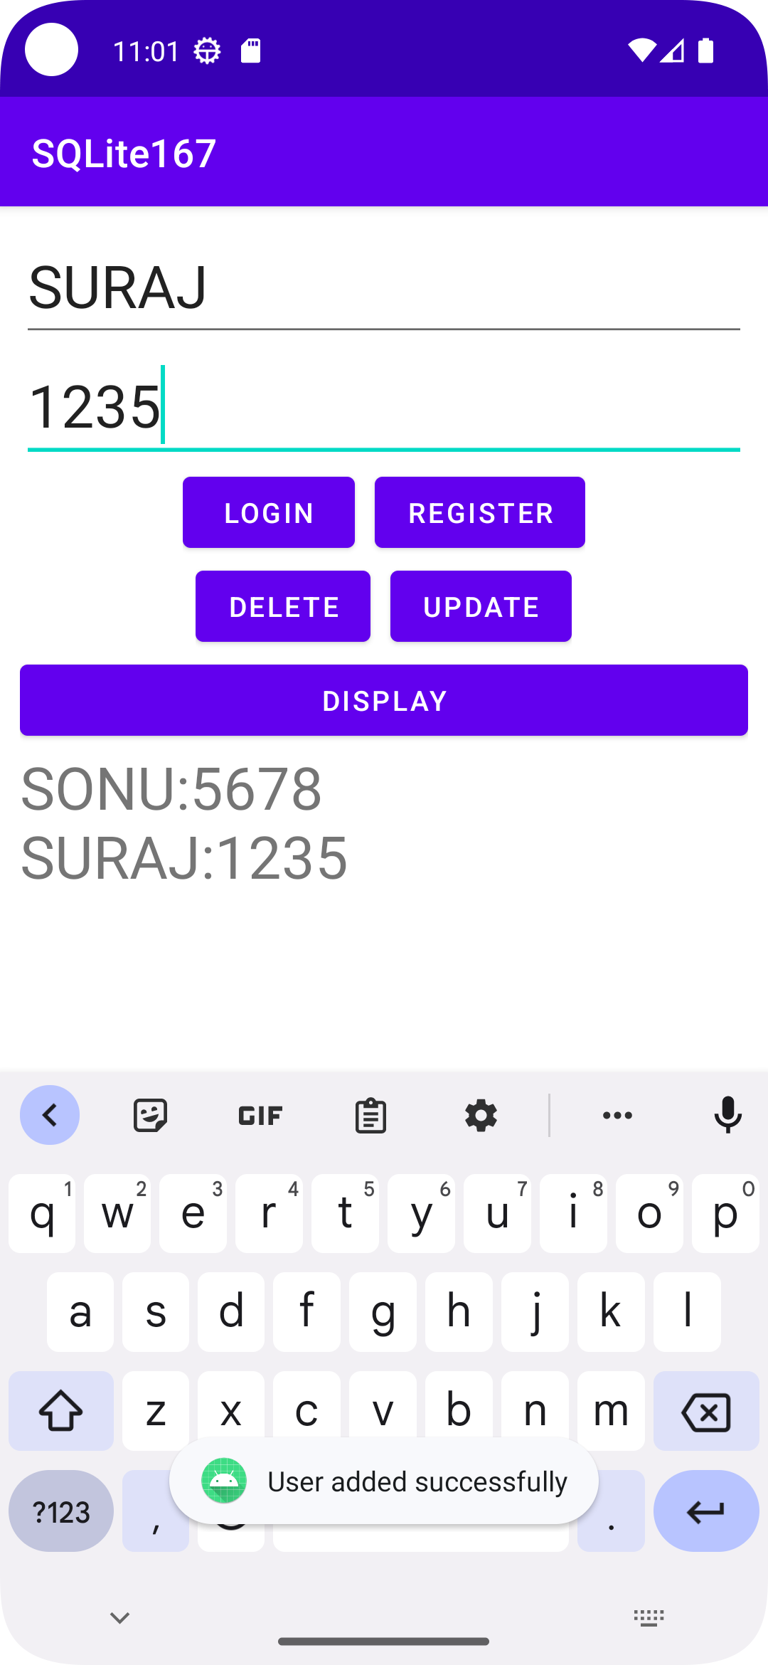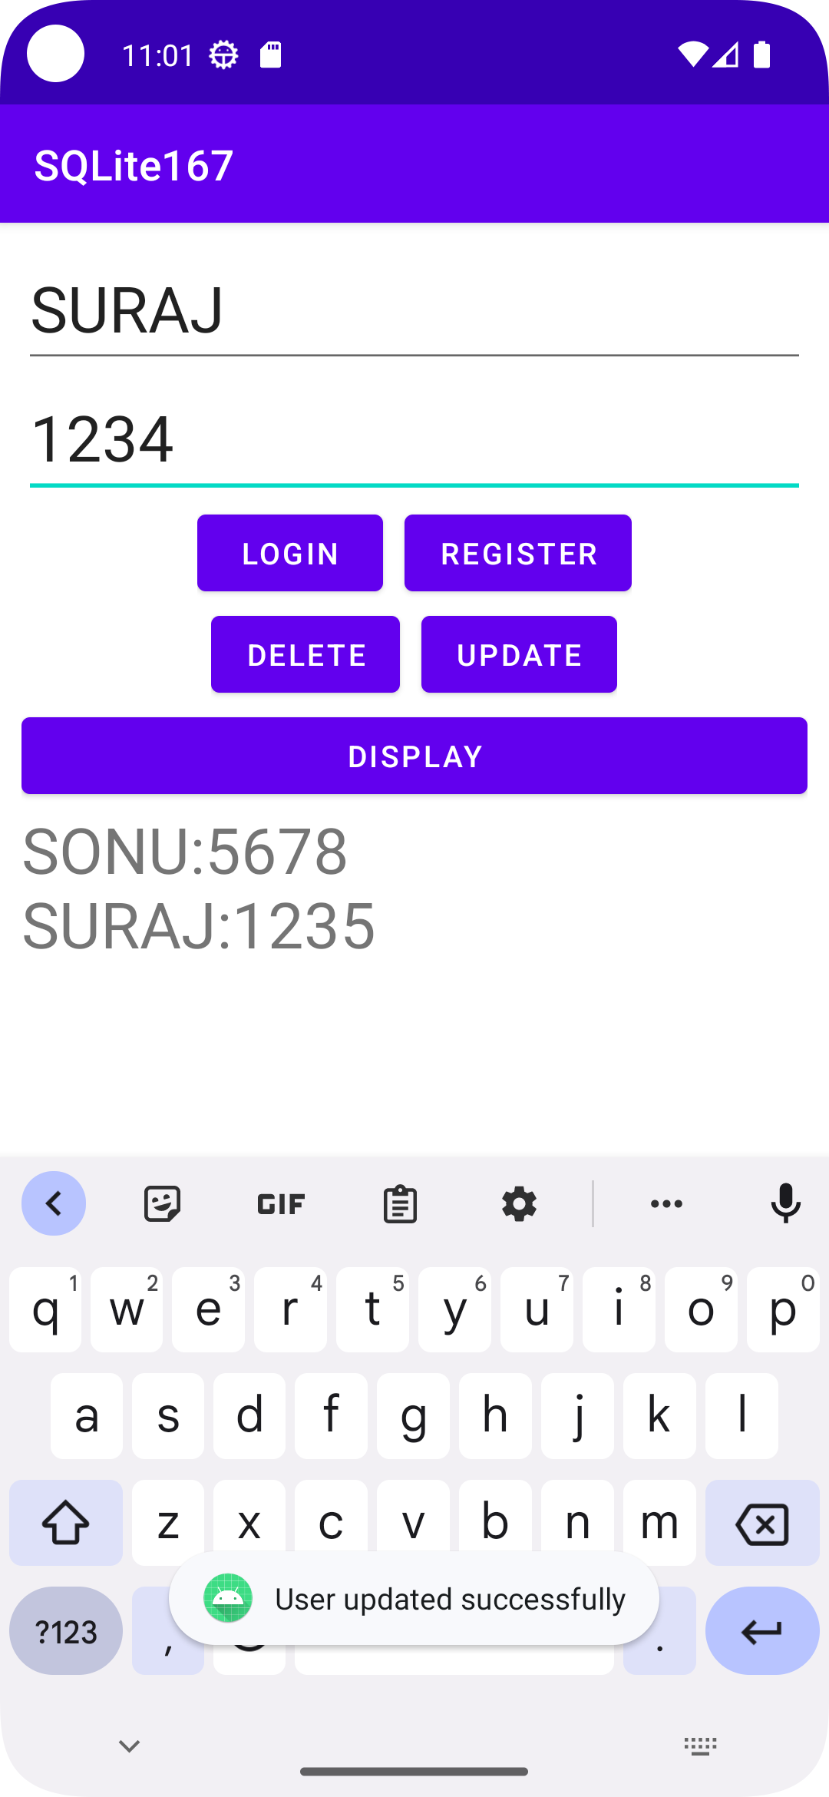

Register Update

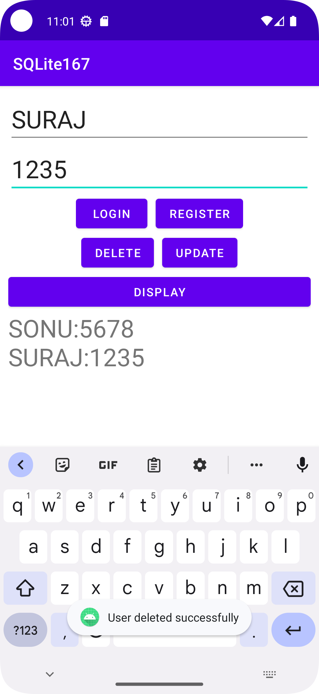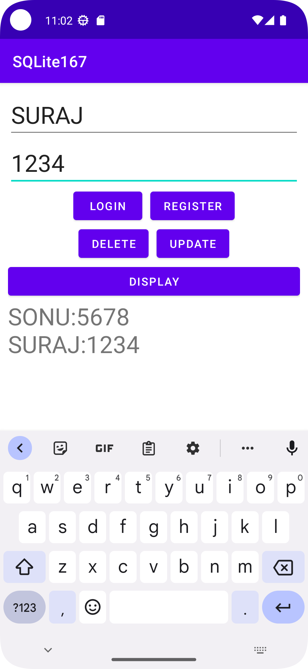

Delete Login

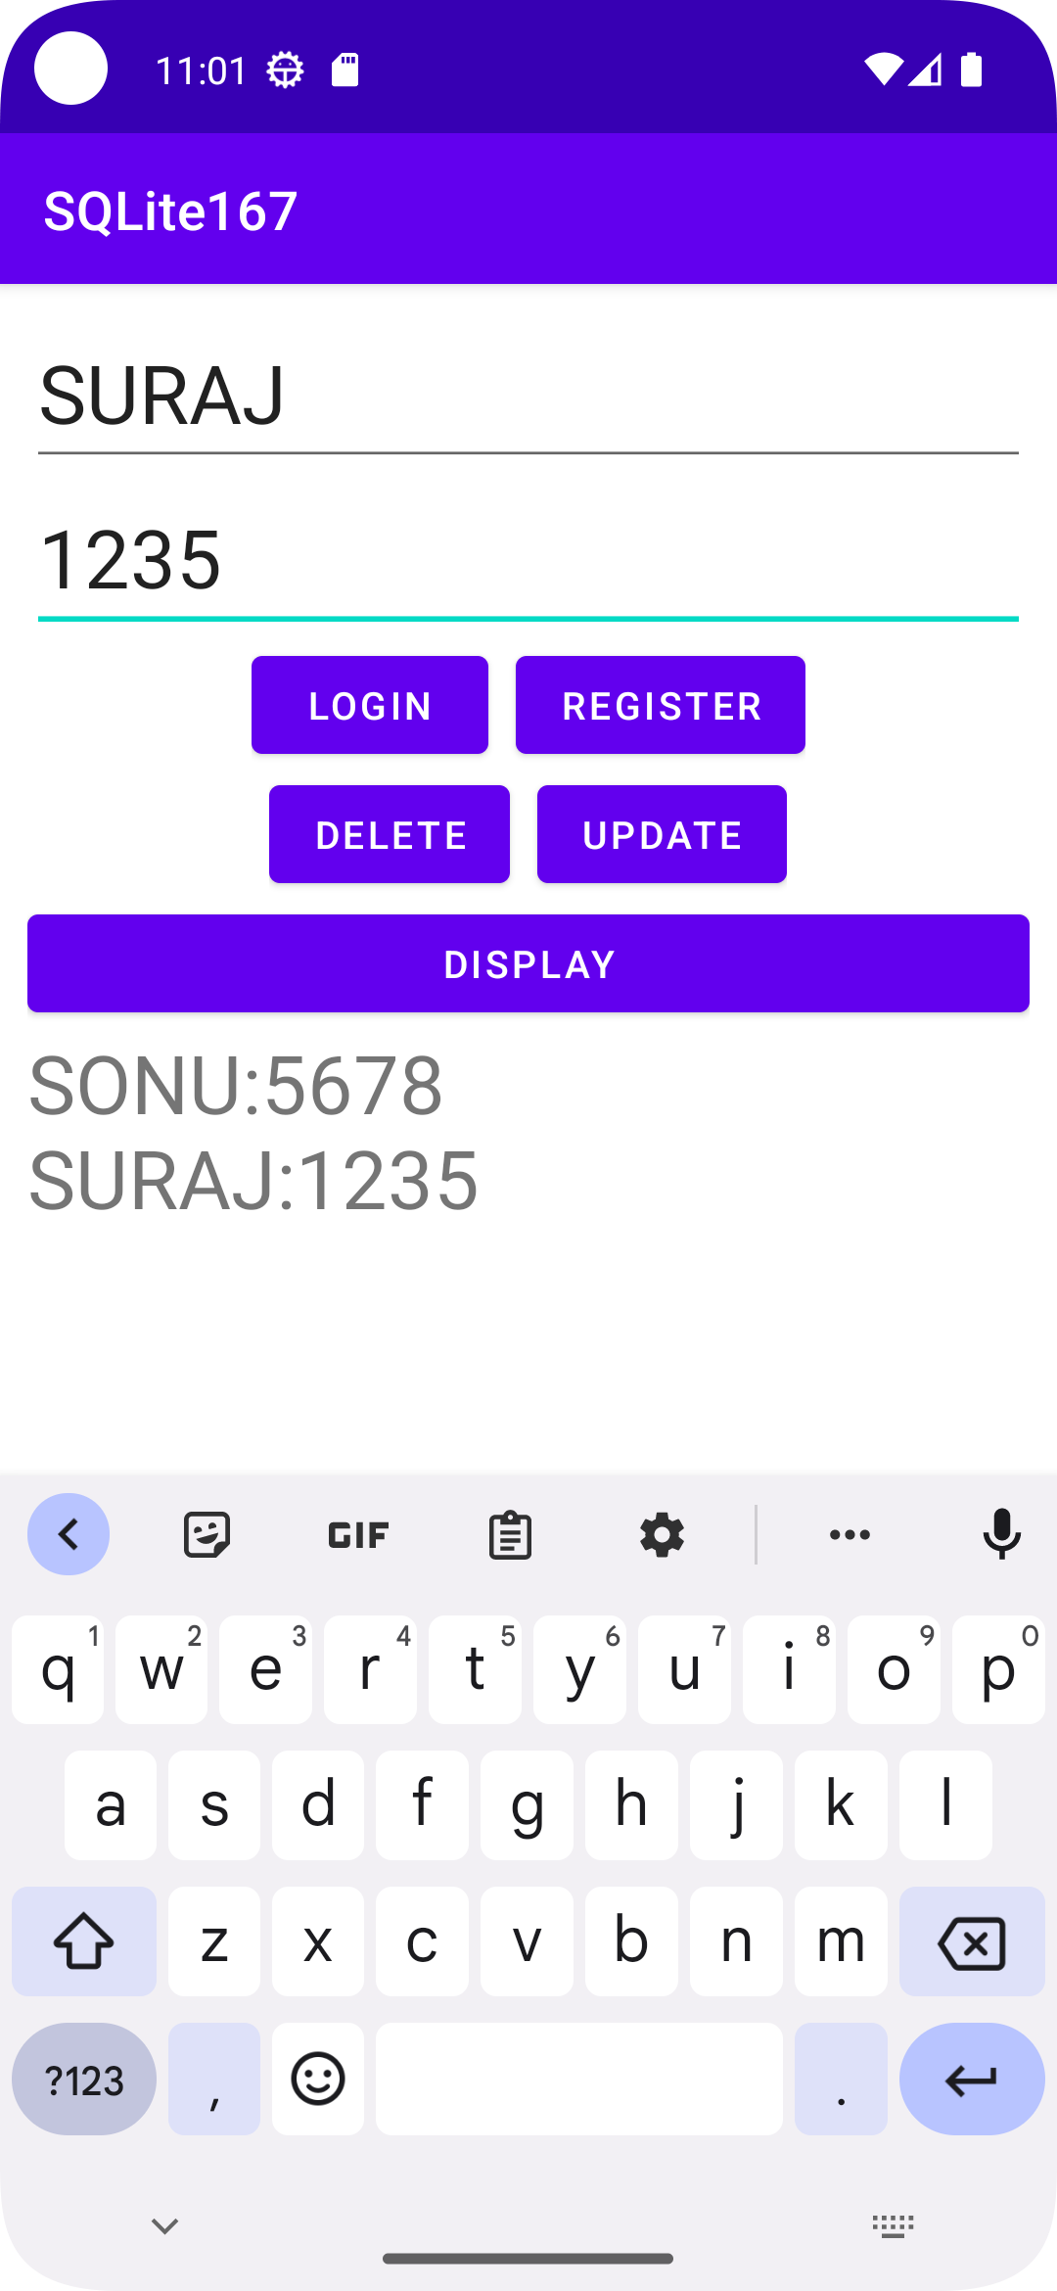

Display

